Question 1:

Dynamic Memory Allocation

The decision to process of allocating memory during program execution is called dynamic memory allocation.

Note: Memory cannot be allocated at compiled time,the difference is only decision postpone. Memory always allocate at run time in both the cases SMA or DMA

Or

Continue…

In C when memory is explicitly allocated, the memory allocating function such as ‘ malloc() ’ ‘ calloc()’ is used. Using this approach we can postpone the decision of the size of the memory block needed until run time. Or it permits us to use as much memory as we want, and then when that memory is no longer needed it can be freed up for other uses.

The memory allocation can be done with the help of following library function :

malloc()

calloc()

realloc()

The memory can be deallocated by following library function :

free()

Note:

All functions are return address.

Default type is void pointer.

Same type of pointer hold same type of address.

malloc() function :

The malloc() function is used to allocate single memory block in bytes.

The syntax of malloc is

pointer = ( typecast * )malloc(size);

For example, to allocate space for 10 integers :

{

int *ptr ;

ptr=(int*)malloc(2*sizeof(int))

Or

ptr = ( int* )malloc (4);

*ptr = 55 ;

}

calloc() function :

The calloc function is used to allocate memory block of contiguous memory in bytes. All block are same size.

The syntax of calloc is

pointer=( typecast*)calloc( n, size) ;

where

n = number of blocks.

Size = size of blocks

Example : int *ptr ;

ptr= (int *)calloc (5,sizeof(int)); Or ptr= ( int * )calloc( 5 , 4 );

*(ptr+0) = 34 ;

*(ptr+1) = 55;

*(ptr+2) = 60;

*(ptr+3) = 40;

*(ptr+4) = 20;
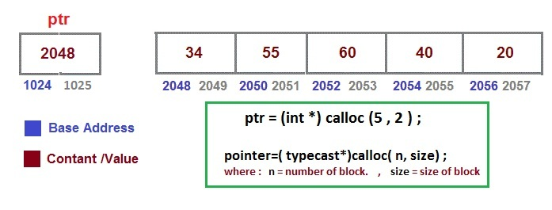

realloc() function :

The realloc function is used to resize the memory block of malloc or calloc variable.

The syntax of realloc is

pointer = (typecast*)realloc( pointer , resize ) ;

For example :

ptr= (int*) malloc (6) ; (before resize, 6 bytes allocated to int pointer ptr)

ptr= (int*) realloc ( ptr , 8) ; (after resize, 10 bytes reallocated to int pointer ptr)

where :

ptr is pointer which we want to resize

8 is the resize value

Memory deallocated function

The free function is used to deallocates the memory previously allocated by a call to calloc, malloc, or realloc.

The syntax of free() is

free(pointer_name) ;

Example:

void fun()

{

int *p ;

p = malloc ( 2 ) ;

- -

- -

free(p) ;

}

Note : Generally written before getch() function.

Example :

#include<stdio.h>

#include<conio.h>

void main()

{

int n,v, *p;

clrscr();

printf("Enter size of block");

scanf("%d",n);

p=(int*)malloc(n);

printf("Address in p is : %u\n",p);

*p=65;

*(p+1)=67;

printf("Value in *p is : %u\n",*p);

//free(p); // free p pointer in free memory area

p=NULL; // Set all value null or 0

printf("Address in p is : %u\n",p);

printf("Value in *p is : %u\n",*p);

printf("Value in p is : %d\n",*(p+1));

getch();

}

Question 2:

Difference between malloc() and calloc()
Malloc() | Calloc()
Malloc takes only one argument and that is size of the block. | Calloc() takes two arguments the first is number of variable/block and second argument is size of each variable/block.
Malloc() does not initialize the memory allocated during execution. It carries garbage value. | Calloc() initialize the allocated memory to zero, But malloc doesn’t .

